User Manual
  - DUTY ROSTER MODULE

  - 

  - All Rights Reserved: Megaplus Technologies
Table of Contents
Starting work on ERP: 2
➢ Login Screen: 3
Login: 3
➢ Duty Roster: 4
Add Shift: 4
Admin Duty Roster: 4
Assign Duty to Employee: 5
Search Duties: 6

Starting work on ERP:
- Open Chrome, Firefox, Safari or Internet Explorer.
- Enter url in URL Bar:
http://192.168.8.94/demo/login.aspx

Login Screen:

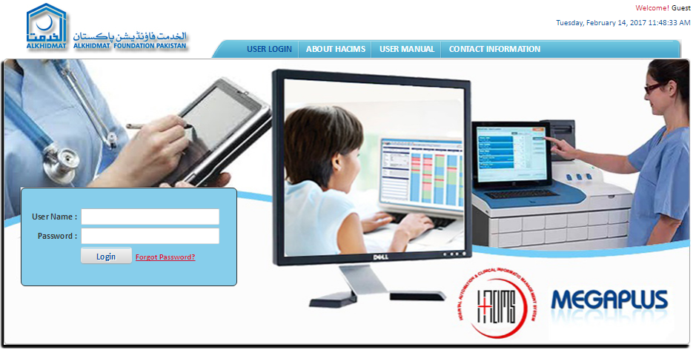

Login:
Enter login details and click on Login.
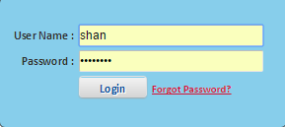

Duty Roster:

Add Shift:
- Select Duty Roster Module from Menu Bar.
- Select Add Shift from Duty Roster menu list.
- Add Shift Name in text box.
- Add Shift Description in text box.
- Add Abbreviation in text box.
- Click on Save button.

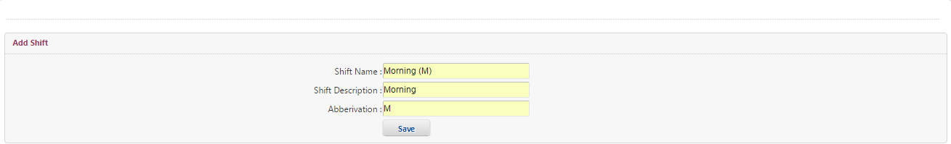

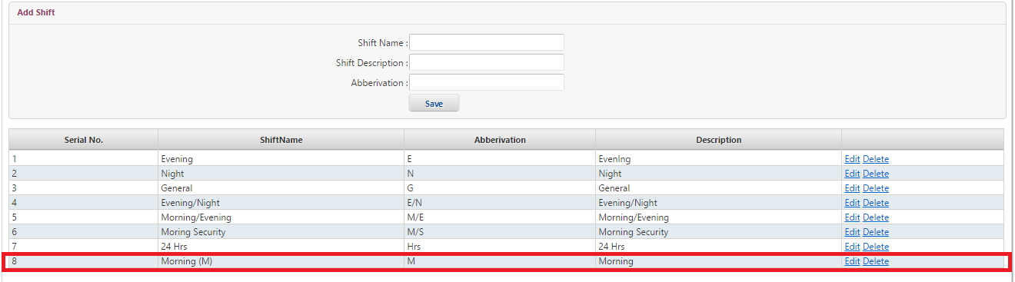

Admin Duty Roster:
- Select Admin Duty Roster from Duty Roster menu list.
- Add Department Name in the text box.
- Add Sub Department Name in the text box.
- Add Shift Name in the text box.
- Add Start time in the text box.
- Add Duration time (hours and minutes) in text boxes.
- Click on Save button
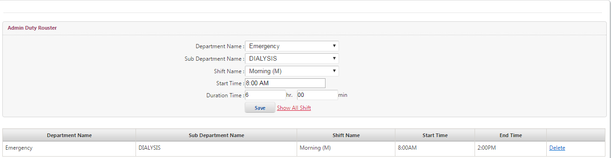

Assign Duty to Employee:
- Select Assign Duty to Employee from Duty Roster menu list.
- Add Start Date from Date chooser.
- Add End Date from Date chooser.
- Select Employee of Department from drop down list.
- Select Employee of Sub Department from drop down list.
- Select Duty Roster for Department from drop down list.
- Select Shift Name from drop down list.
- Select Days of Week from check box list.
- Select Employee Name from check box list to assign duties.
- Click on Save button.

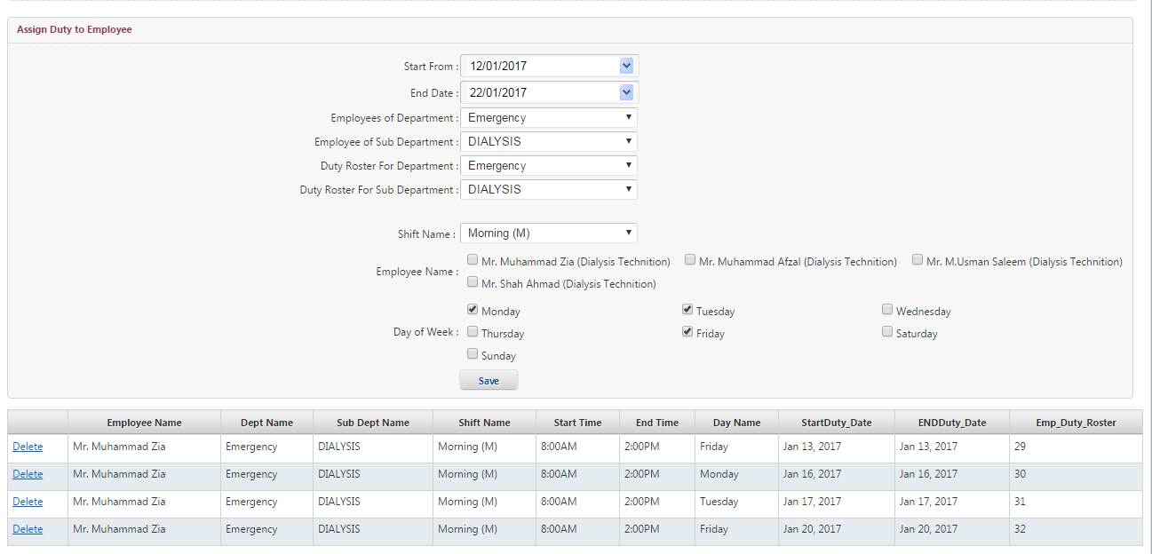

Search Duties:
- Select Search Duties from Duty Roster menu list.
- Select Start Date from date chooser.
- Select End Date from date chooser.
- Select Department Name from drop down list.
- Select Sub Department Name from drop down list.
- Click on Search button.

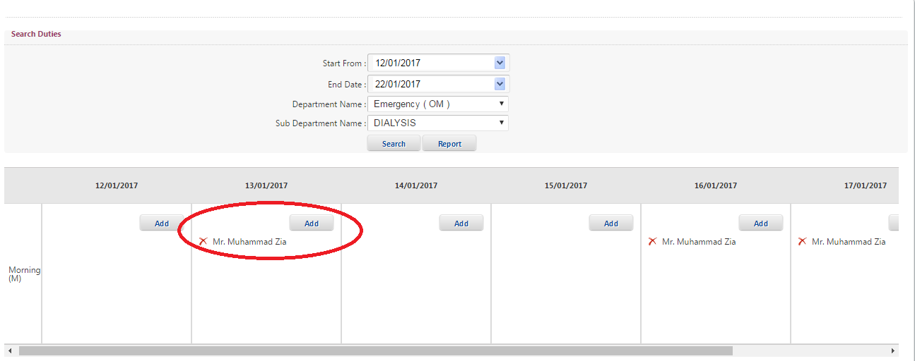
- Add other employee names with same schedule click on Add button

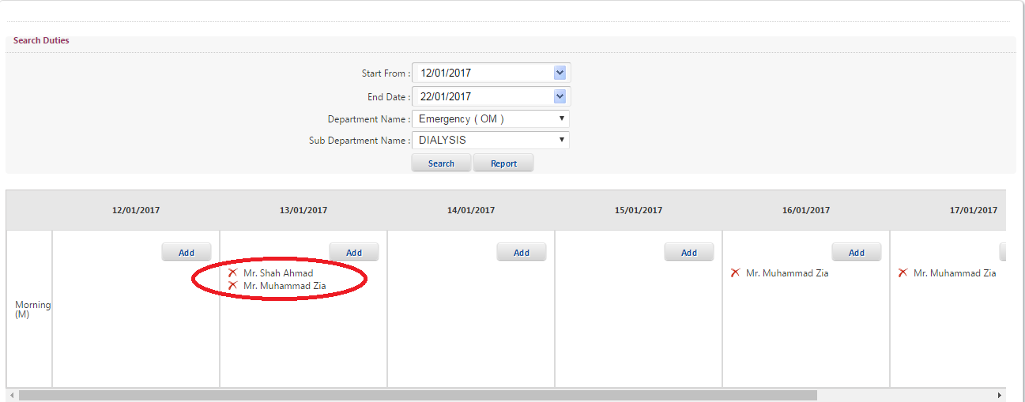

- Click on Report button then Duty Roster report will generate
